**Project Design Phase-II**

**Data Flow Diagram & User Stories**

|  |  |
| --- | --- |
| Date | 26 June 2025 |
| Team ID | LTVIP2025TMID59601 |
| Project Name | orderonthego: your on-demand food ordering solution |
| Maximum Marks | 4 Marks |

**Data Flow Diagrams:**

A Data Flow Diagram (DFD) is a traditional visual representation of the information flows within a system. A neat and clear DFD can depict the right amount of the system requirement graphically. It shows how data enters and leaves the system, what changes the information, and where data is stored.

**Example:** [**(Simplified)**](https://developer.ibm.com/patterns/visualize-unstructured-text/)

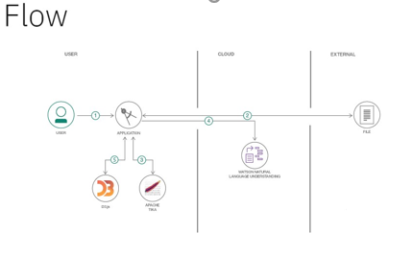 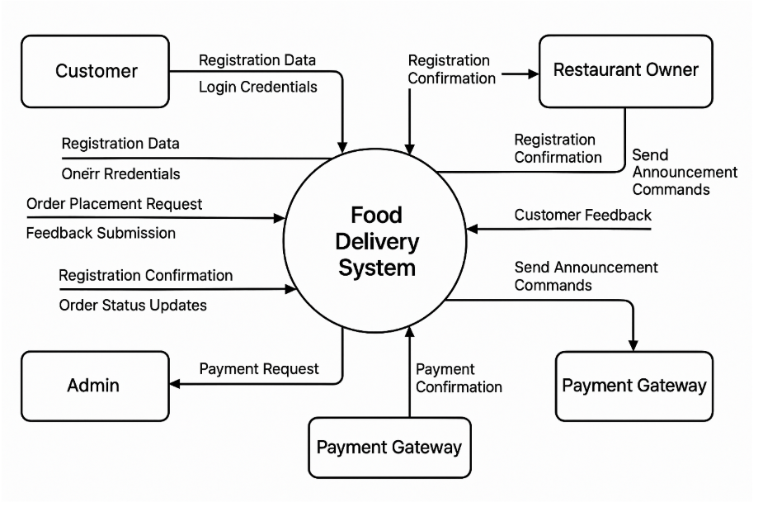

**User Stories**

Use the below template to list all the user stories for the product.

|  |  |  |  |  |  |  |
| --- | --- | --- | --- | --- | --- | --- |
| **User Type** | **Functional**  **Requirement**  **(Epic)** | **User Story**  **Number** | **User Story / Task** | **Acceptance criteria** | **Priority** | **Release** |
| Customer | Registration | USN-1 | As a user, I can register for the application by entering my email and password. | I can access my account / dashboard | High | Sprint-1 |
|  |  | USN-2 | As a user, I can log into the application by entering my email and password. | I can access my dashboard after successful login. | High | Sprint-1 |
|  | Profile Management | USN-3 | As a user, I can view and update my profile information. | I can see my updated name and email on the profile page. | High | Sprint-1 |
|  | Search & Order | USN-4 | As a user, I can view a list of restaurants and their menus. | I can browse different restaurants and see all their available food items. | High | Sprint-1 |
|  |  | USN-5 | As a user, I can add food items to my cart and place an order. | My order is successfully placed and appears in my order history. | High | Sprint-1 |
|  |  | USN-6 | As a user, I can see the status of my order in real-time (e.g., pending, delivered). | The order status updates on my order history page. | High | Sprint-1 |
|  | Feedback | USN-7 | As a user, I can submit feedback for a restaurant. | My rating and comment are saved and visible to the admin. | Medium | Sprint-2 |
| Restaurant Owner | Registration & Approval | USN-8 | As a restaurant owner, I can register and await admin approval. | I am notified once my account is approved by the admin. | High | Sprint-1 |
|  | Restaurant Management | USN-9 | As a restaurant owner, I can add and edit my restaurant's details. | My restaurant's title, address, and image are updated on the website. | High | Sprint-1 |
|  | Menu Management | USN-10 | As a restaurant owner, I can add, edit, and delete food items from my menu. | The menu on my restaurant's page is updated with the new item. | High | Sprint-1 |
|  | Order Processing | USN-11 | As a restaurant owner, I can view new orders and update their status. | I can change an order's status from 'pending' to 'preparing' or 'delivered'. | High | Sprint-1 |
|  | Feedback | USN-12 | As a restaurant owner, I can submit feedback to the admin. | My feedback message is sent to the admin's dashboard. | Medium | Sprint-2 |
| Administrator | User Management | USN-13 | As an admin, I can view a list of all users and their details. | I can see all user accounts (customers, restaurants, admins) in a list. | High | Sprint-1 |
|  |  | USN-14 | As an admin, I can approve or reject new restaurant owner accounts. | The restaurant owner's approval status changes to 'accepted' or 'rejected'. | High | Sprint-1 |
|  | Content Management | USN-15 | As an admin, I can manage (add, edit, delete) food categories for the system. | New categories are available for restaurant owners to use when adding food items. | High | Sprint-1 |
|  | Dashboard & Reports | USN-16 | As an admin, I can view dashboard metrics like total users and orders. | The dashboard shows updated counts for all key metrics. | High | Sprint-1 |
|  |  | USN-17 | As an admin, I can generate reports on order trends and top restaurants. | I can see a chart showing the number of orders over time. | High | Sprint-1 |
|  | System Communication | USN-18 | As an admin, I can send announcements to all users or specific roles. | The announcement appears on the user's dashboard. | Medium | Sprint-2 |